
MINISTRY FOR EDUCATION AND SCIENCE OF RUSSIA
________________________________

SAINT PETERSBURG ELECTROTECHNICAL UNIVERSITY

«LETI»
________________________________

APPROVED
18/03/2021
__________________________
Date, signature

_____________ (( OnMyWay_))_______________________

PROJECT MANAGEMENT PLAN

PMP_S04_

St. Petersburg / Санкт-Петербург

2021

content

Contents
History 3
Project team 3
What is our project? 4
BASIS FOR DEVELOPMENT: 4
DEVELOPMENT GOALS: 4
Detail requirements 4
high level design : 5
Key milstones 6
Architecture of our project: 7
work breakdown structure and efforts estimation: 8
Chosen technology and development framework: 8
configuration and change management : 8
project specific process 8
Why we choice the flutter as a framework? 9
Dart as a language for coding: 10
Who is interested in this project (stakeholders) ? 11
Our progress : 12
Estimation our project by Analog: 13
Use case points: 13
project risks : 16

Teacher
Filippov Evgeny Vasilyevich / Филиппов Евгений Васильевич e.philippov.leti@mail.ru
Ерошкин Александр Владимирович
a.eroshkin@sigma-it.ru

History

 | Date | Short description
SOW -1- | 04/03/2021 | 1-Name of project  2- Idea of project
SOW -2- | 18/03/2021 | - Project Description  - Basics of development  - High level Architecture
PMP | 04/04/2021 | All this paper

Project team

№ | Name | Group | Project role | Contact Information
1 | Bushra Ahmad | 6300 | All application | Bushraahmad407146@gmail.com  +79516522218
2 | Shahrukh Sultan | 6300 | All application | getssultan@gmail.com  +91 8638791167

What is our project?

we want to design an Andriod application , this application will help people in transporting, especially in the countries which transporting isn't available a lot in hole day, so this app make people help themselves and this the Purpose of the system

BASIS FOR DEVELOPMENT:

Android studio/framework-flutter/language-dart/server.
Full name of the project
OnMyWay

DEVELOPMENT GOALS:

The software product is intended to people to give them chance in helping themselves

Detail requirements

Requirements:

- Windows operating system
- Android Studio program
- Windows server 2012
- SQL server 2014

high level design :

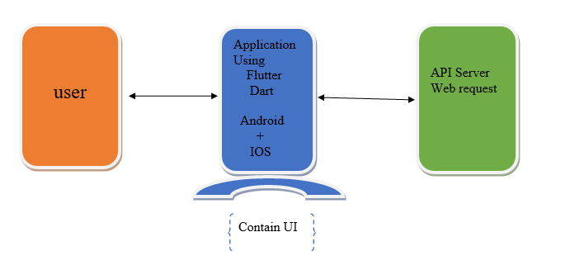

Server:

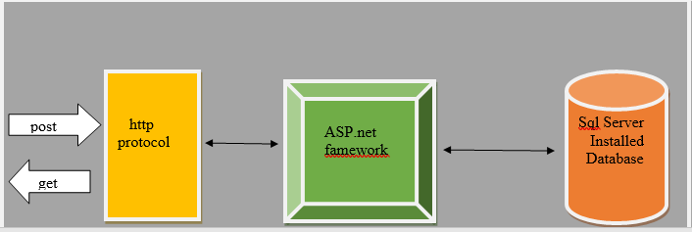

Key milstones

№ | Start date | End date | Description
1 | 01/03/2021 | 18/03/2021 | Determine the project idea and requirements for its application and prepare the tools for its implementation
2 | 2021/03/21 | 2021/04/22 | Learn the Dart language and write the code for designing the user interface and application
3 | 2021/04/23 | 2021/05/20 | Connecting the application with the server, testing the code, and fully realizing the application
4 | 2021/05/20 | 2021/05/25 | Defense

Architecture of our project:

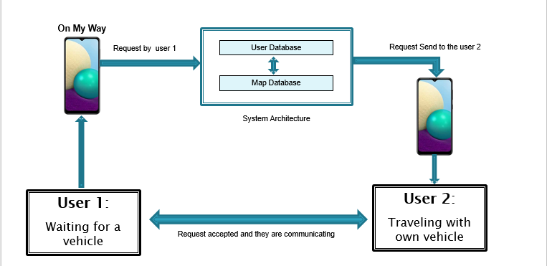

work breakdown structure and efforts estimation:

Total hours

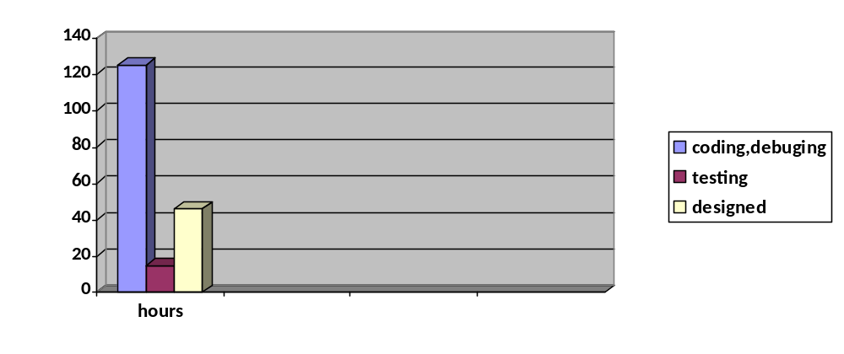

Chosen technology and development framework:
- Flutter: To develop the application framework
- Dart: To write the codes
- Server and Database technologies

configuration and change management :

For our project we want to use Github to store the code and other documents.

project specific process

Development model :
We will use the following development model “Agile model”.

Why we choice the flutter as a framework?

Flutter is an open source software for a suite of software development tools developed by Google to build user interfaces for Android and iOS system applications.

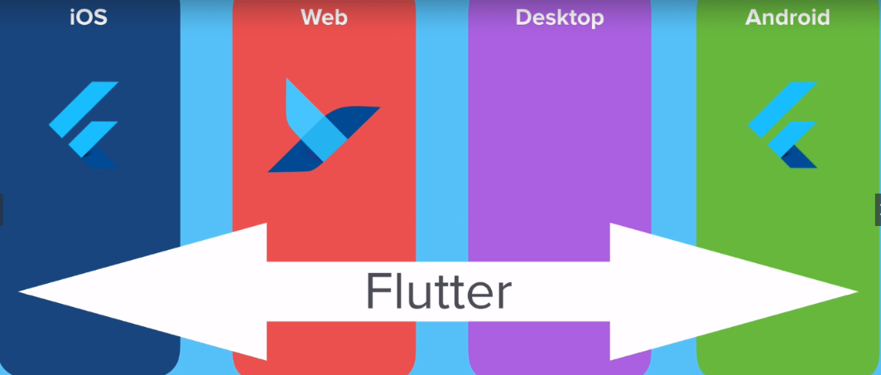

Deal with several screen size

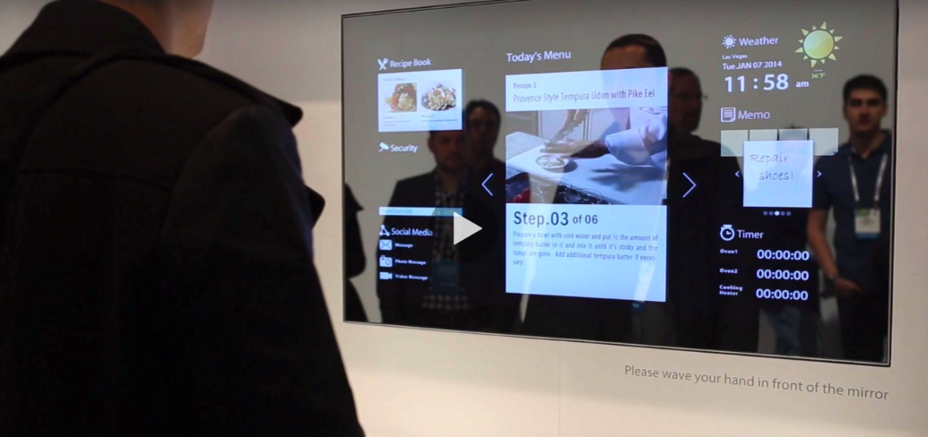

Dart as a language for coding:

1-Ease of learning, You won't waste much time while you are learning it
2-A very flexible language in the sense that you can run it anywhere without any restrictions. You can run Dart applications. For mobile devices on Android - IOS. You can run web applications that you create on any browser
3-Multi-platform.
4-under developing

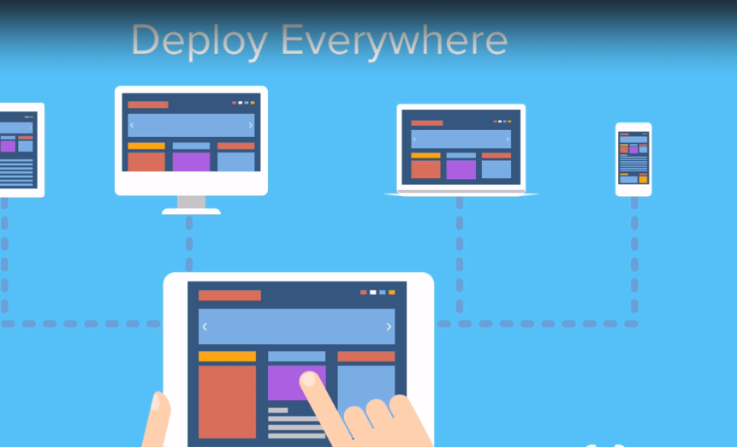

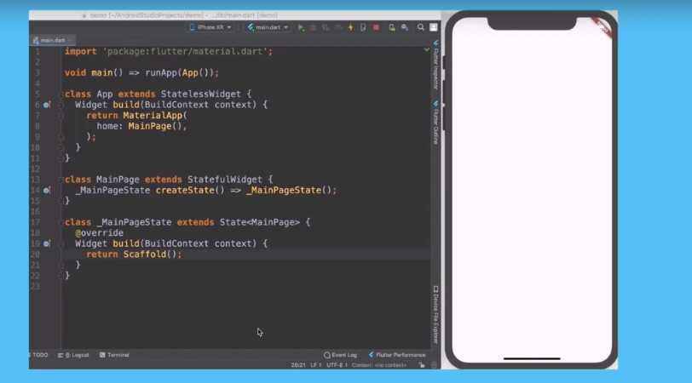

Who is interested in this project (stakeholders) ?
When people have the opportunity to move from one place to another, at a time that suits them, and for free, this is what makes the application the focus of everyone's attention
Many people find great happiness in helping others
the developers of this application when they find a great ability form people to use the application, they may convert it into a business plan and develop it.

Our progress :

we design, coding the first user interfaces

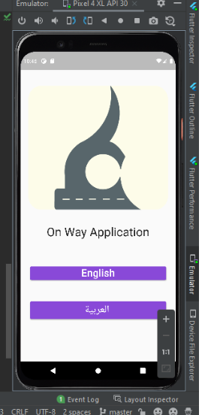

Estimation our project by Analog:

Use case points:
- Number and complexity of actors

Class | Coefficient(ki) | Number of actors(vi)
Simple | 1 | 2
Average | 1 | 1
complex | 1 | 1

Unadjusted Actor Weighting (UAW)=SUM(Ki*Vi)=
1*2+1*1+1*1=4

- Number and complexity of use cases

Class | Coefficient(ki) | Number of use cases(vi)
Simple | 5 | 2
Average | 10 | 1
complex | 15 | 1

Unadjusted Use Case Weighting (UUCW) = SUM ( Ki * Vi )=35

- Technical development factor :

Factor | Description | Coefficient (Ki) | Value (Vi)
T1 | Distributed System | 1 | 1
T2 | Response Time | 3 | 4
T3 | End User Efficiency | 1 | 1
T4 | Complex Processing | 2 | 2
T5 | Reusable Code | 3 | 2
T6 | Installation Ease | 4 | 3
T7 | Usability | 4 | 4
T8 | Portable | 4 | 4
T9 | Easy To Change | 3 | 4
T10 | Highly Concurrent | 2 | 2
T11 | Custom Security | 1 | 2
T12 | Dependence On Third-Party Code | 1 | 1
T13 | User Training | 2 | 1

Technical Complexity Factor (TCF) = 0.6+(0.01*SUM(Ki*Vi))=
0.6+(0.01*89)=1.49

- Environmental factor (experience)

Factor | Description | Coefficient (Ki) | Value (Vi)
T1 | Familiarity With The Project Process | 2.5 | 2
T2 | Application Experience | 1 | 1
T3 | OO Programming Experience | 2.5 | 3
T4 | Lead Analyst Capability | 0.5 | 1
T5 | Motivation | 4 | 3
T6 | Stable Requirements | 3 | 2
T7 | Part Time Staff | 2 | 1
T8 | Difficult Programming Language | 2 | 1.5

Environment Factor (EF) = 1.4+(-0.03*SUM(Ki*Vi))
1.4+(-0.03*37)=0.29

Use case points : final calculation
UCP = (UAW + UUCW) * TCF * EF =16.8519

project risks :

Risk Description | Probability | Impact | severity | Manage the risk | Mitigating action
a lack of experiences in coding with the new language we learn now, which may be affect the implementation of the application. | Medium | High | High | Project Developer | 1-Learn a lot about the problems occure  2- Consult some experts in this field
export the code from windows because ios systems need export from Mac | Low | Low | Low | Project Developer | Virtual system installation

